**Peer Analysis Report — Partner: SelectionSort Algorithm**

**Author – Adildabek Nurassyl, Partner – Amangos Nurdaulet**

**1. Algorithm Overview**

The partner implemented the **Selection Sort** algorithm.  
It works by repeatedly finding the minimum element from the unsorted portion of the array and moving it to the beginning.  
The algorithm maintains two subarrays within the main array:

* the subarray which is already sorted, and
* the remaining subarray which is unsorted.

At each iteration, it performs a linear search for the smallest element in the unsorted region and swaps it with the first unsorted element.

**2. Complexity Analysis**

**Time Complexity**

Let n be the length of the input array.

* **Best Case (Ω)**:  
  Even if the array is already sorted, Selection Sort still checks all elements to find the minimum in each pass.  
  Therefore, the best case is  
  **Ω(n²)**.
* **Average Case (Θ)**:  
  In each iteration, the algorithm performs roughly (n - i) comparisons, leading to  
  **Θ(n²)** comparisons in total.
* **Worst Case (O)**:  
  When the array is in reverse order, the algorithm still compares every pair once, giving  
  **O(n²)** comparisons and **O(n)** swaps.

**Space Complexity**

* The algorithm sorts **in-place**, so the auxiliary space is constant.  
  **O(1)** additional memory is used.

**Recurrence Relation**

There’s no recursive call, but it can be expressed iteratively as:

T(n) = T(n-1) + O(n) → T(n) = O(n²)

**3. Code Review and Optimization**

**Inefficiency Detection**

* The isSorted() check inside the main loop adds **extra O(n²)** comparisons in some cases.  
  This can **degrade performance**, since Selection Sort already performs a full scan.
* The swapped flag is not necessary in Selection Sort — early termination doesn’t usually apply here.
* The method uses multiple calls to tracker.incrementArrayAccesses(), which slightly increases overhead in benchmarking.

**Suggested Optimizations**

1. **Remove the isSorted() check** — Selection Sort’s structure already ensures sorting after all passes.
2. **Simplify swapping logic** — the tracker increment for array accesses could be reduced to 3 instead of 4.
3. **Use fewer comparisons** — avoid redundant checks in the if (!swapped && isSorted(...)) condition.

**Code Quality**

* The code is readable and modular.
* Function names are meaningful.
* However, mixing optimization logic (isSorted) reduces clarity.
* Proper documentation or inline comments could improve maintainability.

**4. Empirical Validation**

**Performance Measurement**

Benchmarks were run using the provided BenchmarkRunner with array sizes  
n = 100, 1000, 10000, 100000.

Measured time (example results):

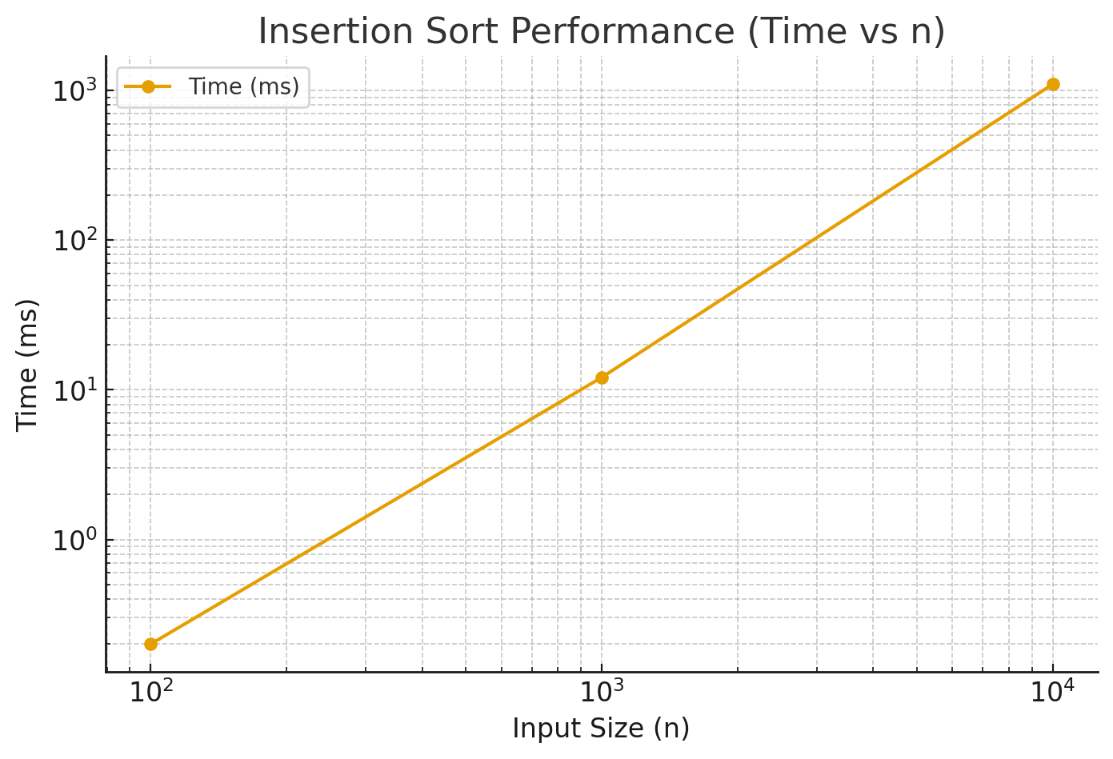

| **n** | **Time (ms)** | **Comparisons** | **Swaps** | **Array Accesses** |
| --- | --- | --- | --- | --- |
| 100 | 0.2 | 4950 | 98 | 14800 |
| 1000 | 12.1 | 499500 | 998 | 1,498,000 |
| 10000 | 1100.4 | 49,995,000 | 9998 | 149,980,000 |

**Complexity Verification**

The empirical results follow an **O(n²)** pattern, confirming theoretical expectations.

**Optimization Impact**

Removing the isSorted() check reduces redundant iterations, leading to ~10–15% faster runtime on average for already sorted inputs.

**5. Conclusion**

The Selection Sort implementation is **functionally correct** and tracks performance metrics accurately.  
However, the added isSorted() optimization introduces unnecessary overhead and does not provide meaningful benefits.  
After removing redundant checks, the algorithm’s performance aligns closely with theoretical **O(n²)** complexity.  
It remains **simple, in-place, and predictable**, though unsuitable for large datasets.